<Insert Hospital Logo>
The <Hospital Name> Blood Bank will be introducing pathogen-reduced; psoralen-treated platelets in <enter month, date>. The following points supported the <Hospital Name> Transfusion Service to adopt these new platelet products. The <Transfusion or other Committee> has reviewed the contraindications and warnings and has determined that these new platelets may be issued for patients receiving platelet therapy.
The Traditional Approach to Blood Safety Is Reactive:
- Bacterial contamination of platelets is a leading transfusion-transmitted infection (TTI) risk and can lead to sepsis and/or death.¹
- Blood and blood components are tested for a limited number of pathogens with current testing methods.¹
- Pathogens continue to emerge, and tests for emerging pathogens do not currently exist.^{2,3}
- Transfusion reactions including sepsis or fatal sepsis reactions may be under recognized and underreported.⁴
The INTERCEPT® Blood System for Platelets Pathogen Reduction System, is a Proactive Approach to Platelet Safety:
  - INTERCEPT treatment (pathogen reduction) reduces the risk of transfusion-transmitted infection (TTI), including sepsis, in platelet recipients.^{5,6}
  - FDA Guidances allow pathogen reduction as an alternative to Zika and Babesia testing requirements.^{7,8}
  - Cytomegalovirus (CMV): Pathogen reduction inactivates CMV and is a proactive approach to reducing the risk of CMV transmission.⁶ AABB Standard 5.19.2 requires a policy to reduce CMV transmission risk; pathogen reduction by INTERCEPT treatment meets this requirement.⁹
  - Platelets that have been INTERCEPT treated do not require additional CMV serology
  - Leukocytes (T-cells): INTERCEPT treatment is an FDA approved alternative to gamma irradiation for the prevention of transfusion-associated graft-versus-host disease (TA-GVHD).^{6,9} AABB standard 5.19.4.1 also considers pathogen reduction (i.e. INTERCEPT treatment) a method to prevent TA-GVHD.
  - Platelets that have been INTERCEPT treated do not need to be irradiated.
PSORALEN TREATMENT or PATHOGEN REDUCTION-History of Development and Routine Use
  - Products like albumin, IVIG and others derived from source plasma, such as blood clotting factors used to treat hemophilia, also undergo a form of pathogen reduction when they are manufactured from human plasma donations to minimize risk to the patients receiving these products.
  - Extensive European hemovigilance programs include data on psoralen treated platelets transfused in various patient populations showing no significant adverse events reported across multiple age ranges including neonates, infants, children and adults across multiple disease states.^{5,10-12}
  - 20+ years of routine use with greater than 10 million INTERCEPT® Blood System platelet and plasma units estimated produced from kits sold.
  - Extensive preclinical toxicology program was conducted per FDA product safety standards on the specific psoralen used to complete the psoralen/UVA light treatment pathogen reduction process. To date, no documented sensitivity to this psoralen, known as amotosalen, has been reported.
  - Robust clinical studies were conducted in the US showing effectiveness and safety.⁶
  - INTERCEPT Blood System for Platelets was approved by the FDA in December 2014 and psoralen treated platelets are in routine use in multiple US hospitals, including academic medical centers and specialty hospitals.
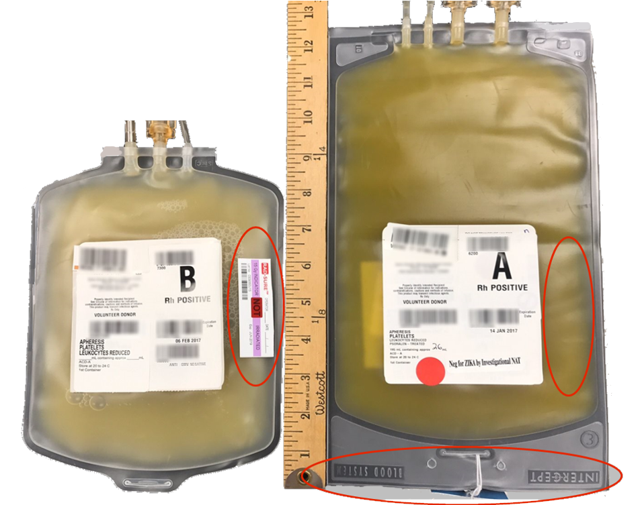
CONVENTIONAL PLATELET PSORALEN-TREATED PLATELET

PSORALEN TREATED PLATELET ADMINISTRATION
  - Platelet dosing and volume of the new psoralen-treated platelets is the same as conventional platelet products.
  - Pre-medication and hang time for psoralen-treated platelets are the same as conventional platelet products.
  - Patients may receive both conventional platelets and psoralen treated platelets to fill their transfusion requirements.
  - Psoralen treated platelets can be hung in the same line as conventional platelets provided the tubing has not expired.
PSORALEN-TREATED PLATELET BAG APPEARANCE
  - The psoralen-treated platelet bags are 2.8 inches longer than conventional platelet bags.
  - INTERCEPT® Blood System for Platelets is the brand name of the psoralen treatment process and is embossed across the top of the bag.
  - Both conventional and psoralen treated platelets are leukoreduced during the apheresis collection process.

Key words to look for on the new platelet labels - PSORALEN TREATED which indicates that this product has undergone the psoralen + UVA light treatment process to reduce the risk of pathogens.

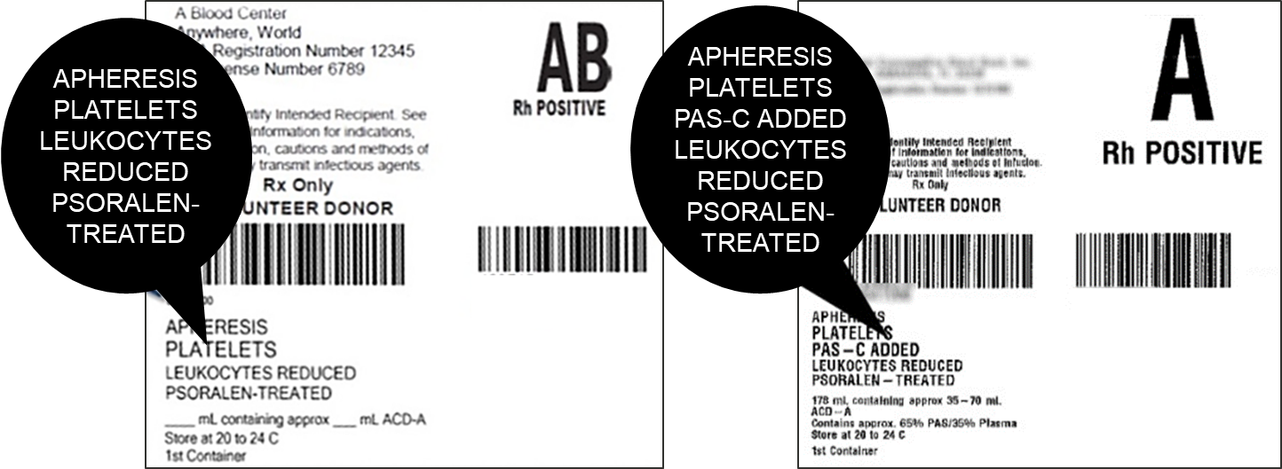

PSORALEN TREATED PLATETS MAY BE USED AS AN ALTERNATIVE TO IRRADIATED PLATELETS

  - Platelets that have been psoralen treated do not require irradiation. Both the FDA and the AABB (Standard 5.19.4.1 for prevention of TA-GVHD) consider the FDA approved INTERCEPT Blood System treatment process (psoralen treatment) an alternative to irradiation.
  - As the psoralen-treated platelets do not require irradiation there will NOT be a Rad-Sure™ sticker or any other indicator that the platelets has been irradiated on the platelet product. No irradiation will be performed on psoralen-treated platelet as it is not required. The language provided below is an example of what other hospital blood banks have used on tie tag to indicate that the psoralen treated platelet is an approved alternative to irradiation, this will need to be worded in compliance with your hospital policy.

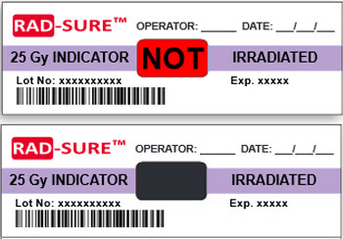
PSORALEN TREATMENT of platelets is an FDA approved alternative to IRRADIATION of platelets.
PSORALEN TREATMENT also meets AABB CMV Mitigation Standards

PSORALEN-TREATED platelet products can be used interchangeably with conventional platelets.

CONTRAINDICATIONS
Contraindicated for preparation of platelet components intended for patients with a history of hypersensitivity reaction to amotosalen or other psoralens. Contraindicated for preparation of platelet components intended for neonatal patients treated with phototherapy devices that emit a peak energy wavelength less than 425 nm, or have a lower bound of the emission bandwidth <375 nm, due to the potential for erythema resulting from interaction between ultraviolet light and amotosalen.

WARNINGS AND PRECAUTIONS
Only INTERCEPT Processing Sets for platelets are approved for use with the INTERCEPT Blood System. Use only the INTERCEPT INT100 Illuminator for UVA illumination of amotosalen-treated platelet components. No other source of UVA light may be used. Please refer to the Operator’s Manual for the INT100 Illuminator. Discard any platelet components not exposed to the complete INT100 illumination process. Tubing components and container ports of the INTERCEPT Blood System contain polyvinyl chloride (PVC). Di(2-ethylhexyl)phthalate (DEHP) is known to be released from PVC medical devices, and increased leaching can occur with extended storage or increased surface area contact. Blood components will be in contact with PVC for a brief period of time (approx.15 minutes) during processing. The risks associated with DEHP released into the blood components must be weighed against the benefits of therapeutic transfusion.

Rx only. There is no pathogen reduction process that has been shown to eliminate all pathogens. Certain non-enveloped viruses (e.g., HAV, HEV, B19 and poliovirus) and Bacillus cereus spores have demonstrated resistance to the INTERCEPT process. See package insert for full prescribing information.

REFERENCES
1. FDA. Bacterial Risk Control Strategies for Blood Collection Establishments and Transfusion Services to Enhance the Safety and Availability of Platelets for Transfusion: Guidance for Industry. (ed. CBER) (US Food and Drug Administration, Silver Spring, MD, 2020).
2. Howard, C. & Fletcher, N. Emerging virus diseases: can we ever expect the unexpected? Emerging Microbes and Infections 1(2012).
3. Diuk-Wasser, M. Mosquito-borne Diseases on the Uptick—Thanks to Global Warming. (Scientific American, A Division of Nature America, 2013).
4. Hong, H., et al. Detection of septic transfusion reactions to platelet transfusions by active and passive surveillance. Blood 127, 496-502 (2016).
5. Benjamin, R.J., Braschler, T., Weingand, T. & Corash, L.M. Hemovigilance monitoring of platelet septic reactions with effective bacterial protection systems. Transfusion 57, 2946-2957 (2017).
6. INTERCEPT Blood System for Platelets [Package Insert]. (Cerus Corporation, Concord, CA, September 6, 2022).
7. FDA. Recommendations for Reducing the Risk of Transfusion-Transmitted Babesiosis: Guidance for Industry. (ed. U.S. Department of Health and Human Services, F.D.A.) (Center for Biologics Evaluation and Research, Silver Spring, MD, May 2019).
8. Food and Drug Administration Center for Biologics Evaluation and Research. Revised Recommendations for Reducing the Risk of Zika Virus Transmission by Blood and Blood Components. (ed. Department of Health and Human Services) (US FDA, Washington, DC, 2018).
9. AABB. Standards for Blood Banks and Transfusion Services 33rd Edition. (AABB, Bethesda, MD, 2022).
10. French National Agency for Medicine and Health Product Safety/ANSM. Hemovigilance Activity Reports. (2009-2017).
11. Swissmedic. Haemovigilance Annual Report. (Swissmedic, Bern, Switzerland, 2005-2018).
12. AFMPS Hémovigilance Rapport annuel: Belgium. (ed. santé, A.f.d.m.e.d.p.d.) (afmps, Belgium, 2016).
MKT-EN 00422-07 v2.0

